|  |
| --- |
| BSHC4, BSHCE4, BSHBIS4, BSHBISE4 |
| Requirements Specification (RS) |
| Team Guide |

|  |
| --- |
| Stephen Woods  21/10/2012 |

Requirements Specification (RS)

Document Control

Revision History

|  |  |  |  |  |  |
| --- | --- | --- | --- | --- | --- |
| **Date** | **Version** | **Scope of Activity** | **Prepared** | **Reviewed** | **Approved** |
| 14/10/2005 | 1 | Create | AB | X | X |
| 21/10/2005 | 2 | Update | CD |  |  |

Distribution List

|  |  |  |
| --- | --- | --- |
| **Name** | **Title** | **Version** |
| Stephan Weibelzahl | Lecturer |  |
|  |  |  |
|  |  |  |
|  |  |  |
|  |  |  |

Related Documents

|  |  |
| --- | --- |
| **Title** | **Comments** |
| Title of Use Case Model |  |
| Title of Use Case Description |  |

**Table of Contents**

1 Introduction 3

1.1 Purpose 3

1.2 Project Scope 3

2 User Requirements Definition 3

3 Requirements Specification 4

3.1 Functional requirements 4

3.1.1 Use Case Diagram 4

3.1.2 Requirement 1: View Fixtures 5

3.1.3 Requirement 2: Pitch Directions 6

3.1.4 Requirement 3: Ref Reports 8

3.1.5 Requirement 4: Club Contact Details 10

3.1.6 Requirement 5: Referee Contact Details 12

3.1.7 Requirement 6: View League Table 14

3.1.8 Requirement 7: View Results 16

3.2 Non-Functional Requirements 18

3.2.1 Security requirement 18

3.2.2 Reliability requirement 19

3.2.3 Maintainability requirement 19

Interface requirements 20

3.3 GUI 20

3.4 Application Programming Interfaces (API) 25

4 System Architecture 25

5 System Evolution 25

# Introduction

## Purpose

The purpose of this document is to set out the requirements for the development of an Android App and a web interface. It will explain what the system will do and what is being used to create the system. The App will provide the user with information about junior football teams e.g. fixtures, results, contact details and pitch directions. The App will also allow referees to submit match reports to the league from the App. The web interface will allow the information to be updated and changed when necessary.

The intended customers are the players, managers, parents and referees or anyone that has an involvement in junior football teams.

## Project Scope

The scope of the project is to develop a user friendly Android App that will provide the user with up-to-date information regarding junior football teams. The App will provide the user with information about fixtures, results, league tables & contact details. The user will also be able to access pitch directions through the Google Maps ApI.

Referees will be able to submit match reports from the TeamGuide App. They will be able to access the list of players registered for each team and will be able to highlight any cards shown to certain players. The web interface, will allow the administrator to update details when it is needed.

# User Requirements Definition

* As a player or manager or parent I want to be able to view our fixtures
* As a player or manager or parent I want to be able to view our league table
* As a player or manager or parent I want to be able to view previous results.
* As a manager or parent or referee I want to be able to get driving directions to the oppositions pitch.
* As a manager or referee I want to be able to get contact information for other clubs.
* As a manager I want to be able to get contact information for referees.
* As a referee I want to be able to easily and quickly submit match reports after each game.

# Requirements Specification

## Functional requirements

### Use Case Diagram

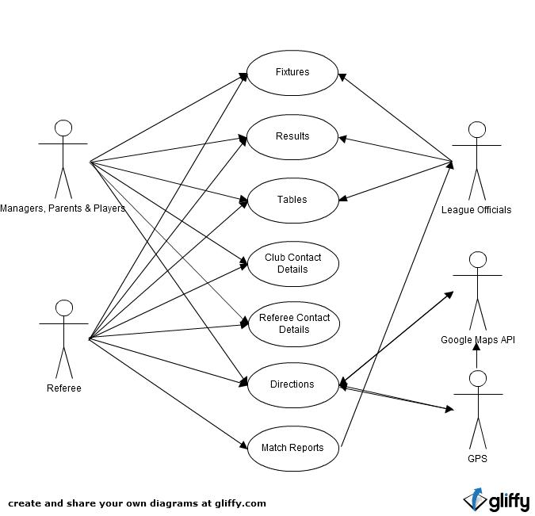

### Requirement 1: View Fixtures

#### Description & Priority

The user can view the list of fixtures for the coming weekend. High priority

#### Use Case

**Scope**

The scope of this use case is to allow the user to select a league and view the fixtures for the coming week.

**Description**

This use case describes the steps required to allow the actor to view the list of fixtures

**Use Case Diagram**

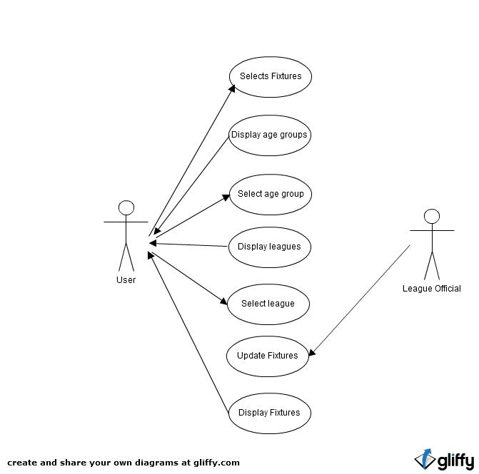

**Flow Description**

**Precondition**

The system is in initialisation mode when the phone is on and the application is running with internet access.

**Activation**

This use case starts when an Actor has selected Fixtures from the main menu

**Main flow**

1. The Actor selects Fixtures on the menu
2. The System responds by showing a list of age groups available
3. The Actor selects an age group
4. The System displays a list of leagues for the selected age group
5. The Actor selects a league.
6. The System displays the fixtures for the selected league

**Alternate flow**

A1: Fixtures unavailable

1. The system displays a message and asks the user to try again later

**Post condition**

The system presents the list of fixtures

### Requirement 2: Pitch Directions

#### Description & Priority

The user can get directions to the other team’s pitches. High priority

#### Use Case

**Scope**

The scope of this use case is to allow the user to get directions to the opposition teams pitches using GPS and the Google Maps API

**Description**

This use case describes the required steps needed to allow the user to obtain directions to the opposition teams pitches.

**Use Case Diagram**

**Flow Description**

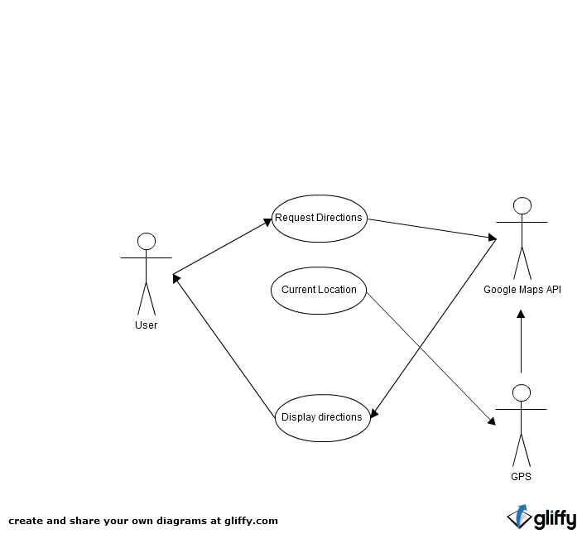

**Precondition**

The system is in initialisation mode when the phone is on and the app is running. GPS and internet access is switched on.

**Activation**

This use case starts when an Actor selects directions from the Fixture List or from the Team Details Menu

**Main flow**

1. The Actor selects directions from the list of fixtures
2. The system loads the Google Maps API and locates the user’s current position through GPS. The system then returns directions from the actors current position to the pitch location

**Alternate flow**

A1: Fixtures not updated

1. The system is unable to provide directions

1. The Actor navigates to the Team page and selects the opposition team.
2. The System displays the team details
3. The Actor selects pitch directions
4. The use case continues at position 2 of the main flow

**Termination**

The system presents the directions to the selected pitch

**Post condition**

The system goes into a wait state

### Requirement 3: Ref Reports

#### Description & Priority

The referee can submit match reports. High priority

#### Use Case

**Scope**

The scope of this use case is to allow the referee to log into the system and submit match reports

**Description**

This use case describes the steps required to allow the referee to submit his match reports.

**Use Case Diagram**

**Flow Description**

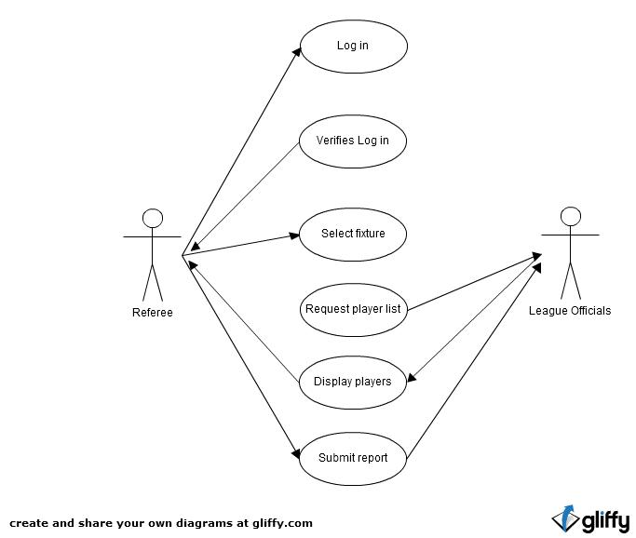

**Precondition**

The system is in initialisation mode when the phone is on and the app is running with internet access.

**Activation**

This use case starts when the Actor selects the Referee option from the menu.

**Main flow**

1. The system identifies the Actor has select the Referee option from the menu.
2. The Actor logs in with their username and password.
3. The System verifies the details and allows access.
4. The Actor selects the match that they wish to report on.
5. The System displays the players registered for each team.
6. The Actor does the match report
7. The System records the match report

**Alternate flow**

A1: Incorrect log in

1. The system returns and error message and asks the user to try again
2. The use case continues at position 2 of the main flow

**Termination**

The system records the submitted match report

**Post condition**

The system goes into a wait state

### Requirement 4: Club Contact Details

#### Description & Priority

The user can access the contact info for other clubs. Medium priority

#### Use Case

**Scope**

The scope of this use case is to allow the user to access the contact information for other clubs

**Description**

This use case describes the steps required to allow the user to access the contact information for other clubs.

**Use Case Diagram**

**Flow Description**

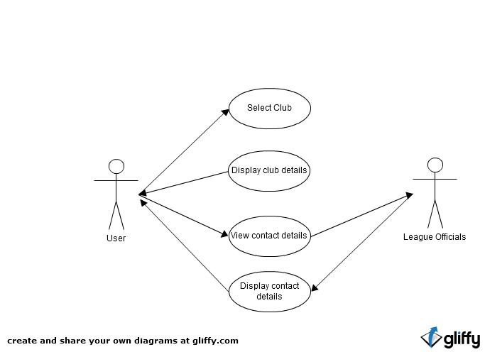

**Precondition**

The system is in initialisation mode when the phone is on and the app is running with internet access.

**Activation**

This use case starts when an Actor selects Clubs from the main menu

**Main flow**

1.The system identifies the Clubs option has been selected and opens up the page.

2. The Actor selects the club they want the contact details for.

3. The System returns the clubs page.

4. The Actor selects to view contact details.

5. The System returns the contact details

**Alternate flow**

A1: No contact details

1. The system returns an error message and displays contact details for the relevant league official.

**Termination**

The system presents the selected clubs contact details

**Post condition**

The system goes into a wait state

### Requirement 5: Referee Contact Details

#### Description & Priority

The user can access the contact details for referees. Medium priority

#### Use Case

**Scope**

The scope of this use case is to allow the user to access the contact details for referees

**Description**

This use case describes the steps required to allow the user to access the referee contact details.

**Use Case Diagram**

**Flow Description**

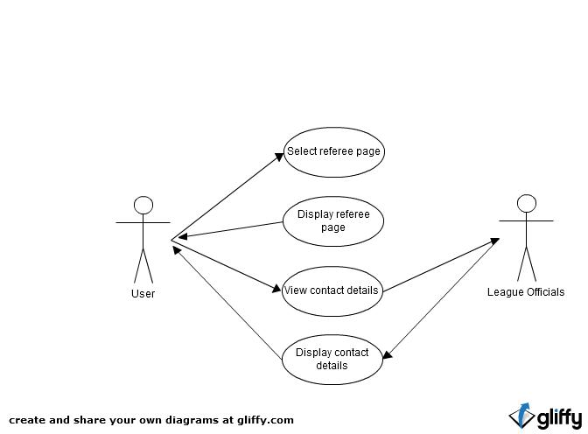

**Precondition**

The system is in initialisation mode when the phone is on and the app is running with internet access.

**Activation**

This use case starts when an Actor selects Referees from the main menu.

**Main flow**

1. The System identifies the selected option and displays the Referee’s page.
2. The Actor selects contact details
3. The System provides a list of referees and their contact details

**Alternate flow**

A1: No contact details

1. The system returns an error message and displays contact details for the relevant league official.

**Termination**

The system presents the referee’s contact details

**Post condition**

The system goes into a wait state

### Requirement 6: View League Table

#### Description & Priority

The user can view the league table for each league. Medium priority

#### Use Case

**Scope**

The scope of this use case is to allow the user to view the league table of their choice.

**Description**

This use case describes the steps required to allow the user to view the league tables

**Use Case Diagram**

**Flow Description**

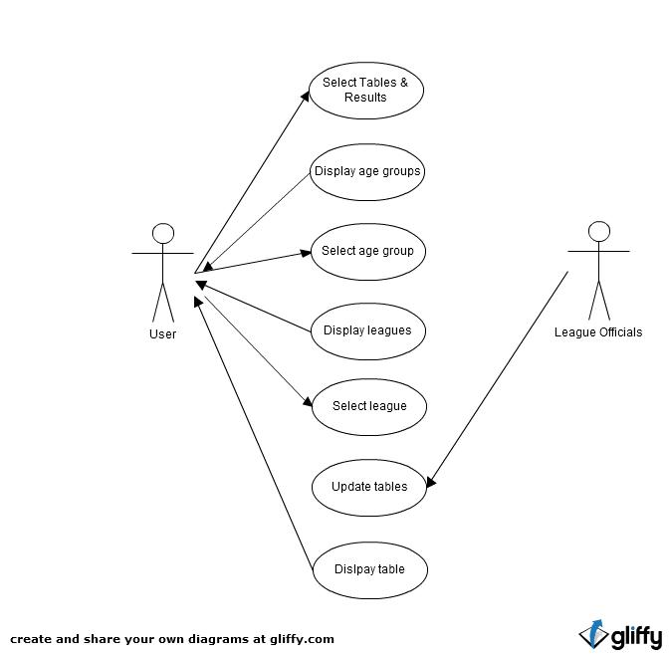

**Precondition**

The system is in initialisation mode when the phone is on and the application is running with internet access.

**Activation**

This use case starts when an Actor has selected Tables & Results from the main menu.

**Main flow**

1. The System identifies the selected option and displays the Tables & Results page.
2. The Actor selects the age group
3. The System displays a list of leagues for the selected age group
4. The Actor selects a league.
5. The System displays the league table for the selected league

**Alternate flow**

A1: Tables unavailable

1. The system displays an error message and asks the user to try again later.

**Termination**

The system displays the league table

**Post condition**

The system goes into a wait state

### Requirement 7: View Results

#### Description & Priority

The user can view previous results in a selected league. Medium priority

#### Use Case

**Scope**

The scope of this use case is to allow the user to view previous league results.

**Description**

This use case describes the steps required to allow the user to view previous results

**Use Case Diagram**

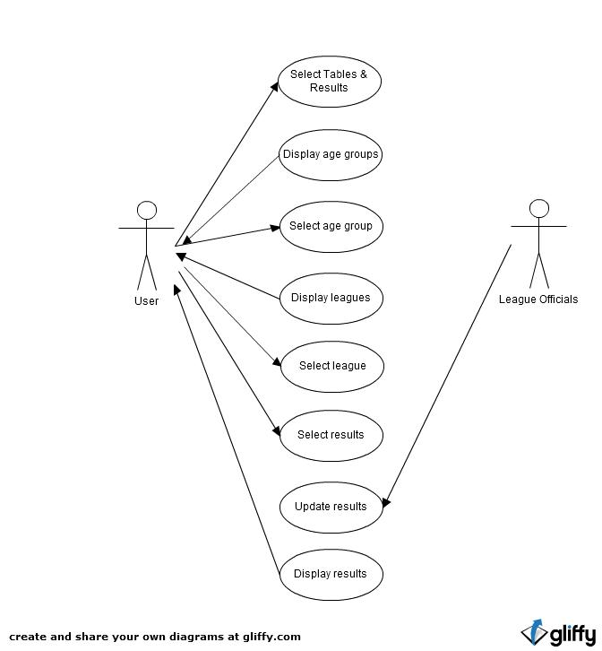

**Flow Description**

**Precondition**

The system is in initialisation mode when the phone is on and the application is running with internet access.

**Activation**

This use case starts when an Actor has selected Tables & Results from the main menu

**Main flow**

1. The System identifies the selected option and displays the Tables & Results page.
2. The Actor selects the age group
3. The System displays a list of leagues for the selected age group
4. The Actor selects a league.
5. The System displays the league table for the selected league
6. The Actor selects results from the menu
7. The System displays previous results from that league.

**Alternate flow**

A1: Tables unavailable

1. The system displays an error message and asks the user to try again later.

A2: Results unavailable

1. The system displays an error message and asks the user to try again later.

**Termination**

The system displays the list of previous results.

**Post condition**

The system goes into a wait state

## Non-Functional Requirements

### Security requirement

There should be a log in section for referees. The referees will be able to submit match reports and results to the league from this section.

### Reliability requirement

The information that the system provides needs to be reliable. The system should update the information on the app as soon as it is made available from the league.

### Maintainability requirement

The system will provide a web interface so that the information can be updated easily and the app can access this information quickly when it is requested.

# Interface requirements

## GUI

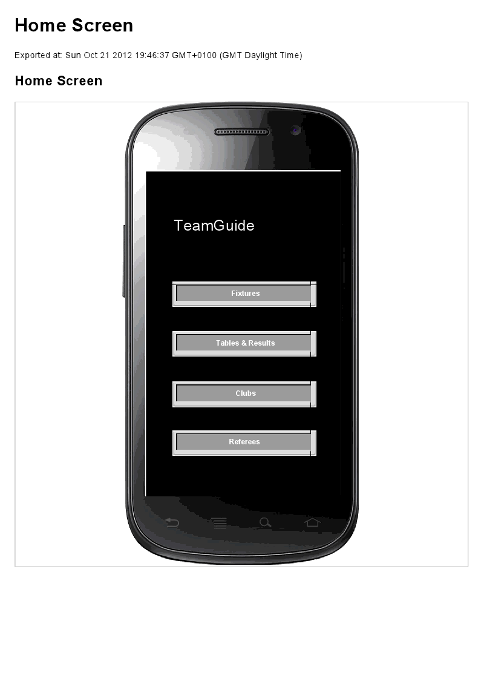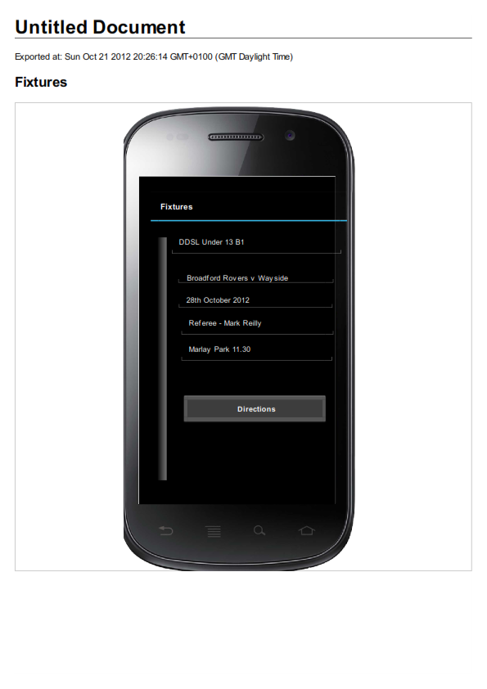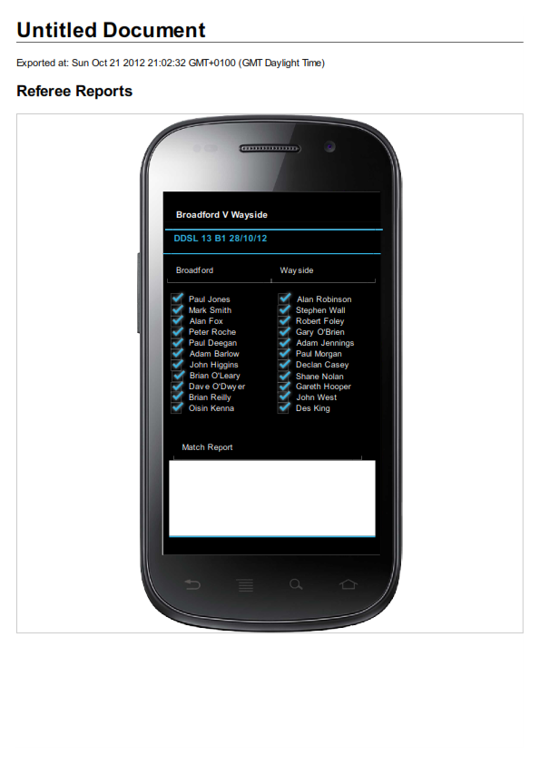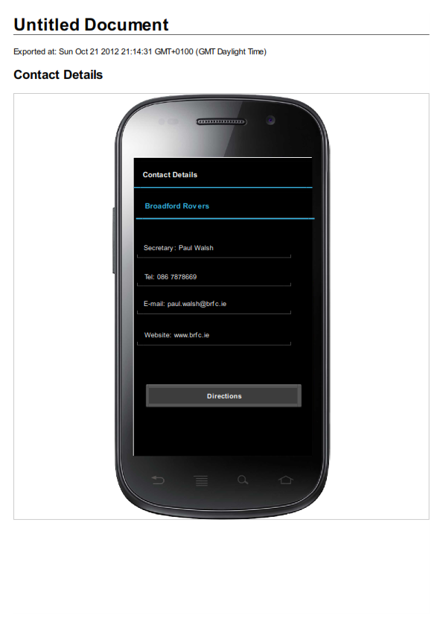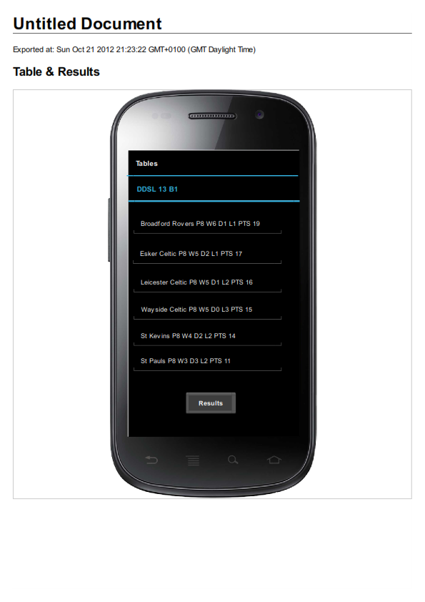

## Application Programming Interfaces (API)

The TeamGuide app will access the Google Maps API to provide the user with directions to opposition pitches. It will use GPS to ascertain the users current position and in turn provide directions to the selected pitch

# System Architecture

Use a class diagram to outline the structure of the system. Explain briefly why you have chosen this architecture. You might want to use Visio or Rational Rose to create these.

# System Evolution

In the future this system can be adapted to include other sports such as GAA and Rugby. The system can adapt to be able to send information direct to managers, referees etc by e-mail or SMS.